PRODUCT CARD SARGAS
Cat. no. 1210

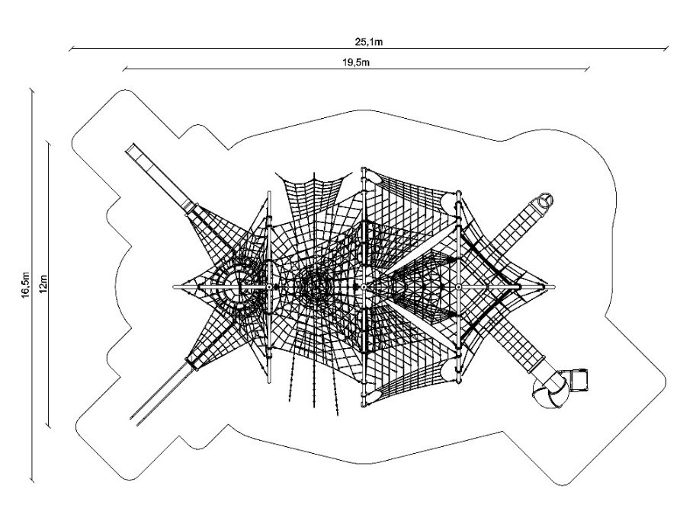

Device dimensions:
Length: 19.5 m
Width: 12.0 m
Height: 5.2 m
Minimum space: 25.1 x 16.5 m
Age group: 5 to 14 years
Free fall height: 3.0 m
Foundation depth: 1.0 m

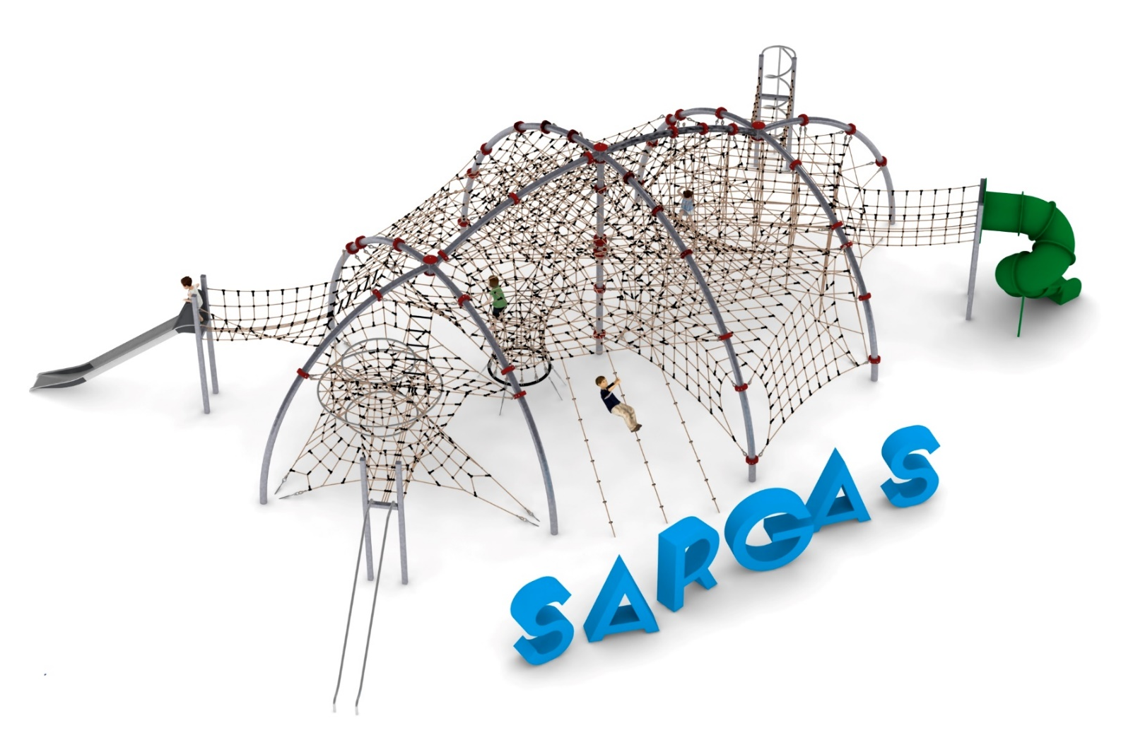

Guidelines for materials and technology of construction of the device.
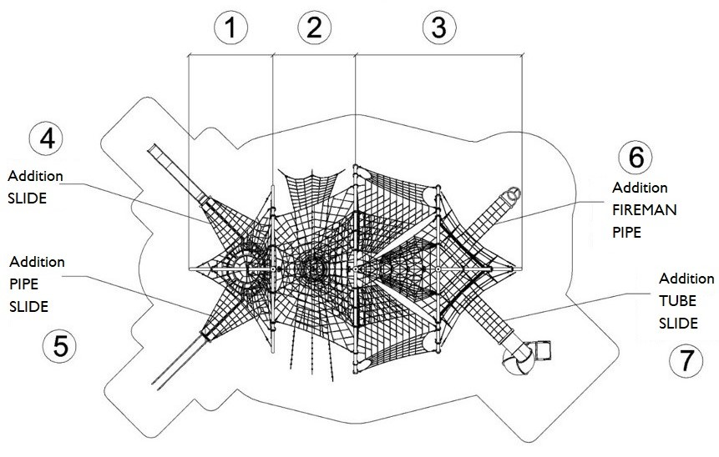
The main structural elements are steel arches made of 139.7 mm diameter pipe. The arches are fixed in the ground with reinforced concrete footings. The structure is protected against corrosion by hot-dip galvanisation. A cable jacket is attached to the steel structure by means of clamps made of cast steel. The cable jacket consists of three sections and four additions:

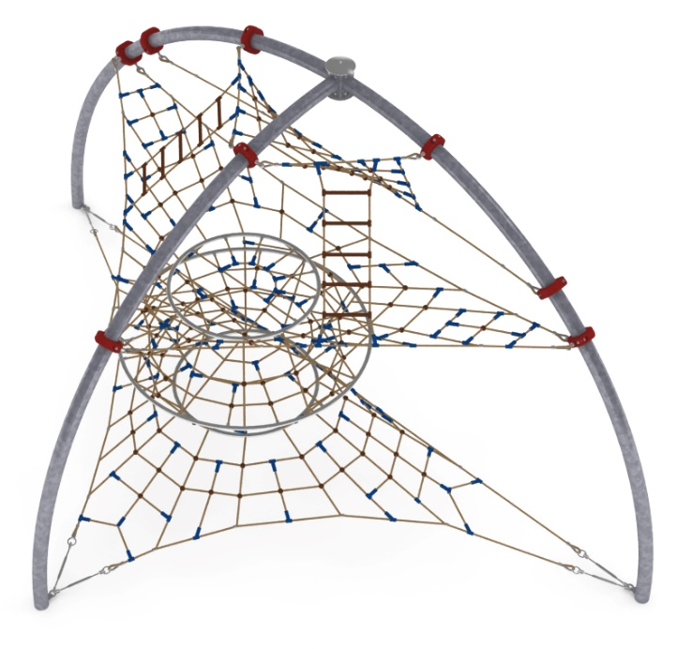
1. SECTION 1
Section 1 consists of:
- a double hourglass-shaped main net installed between three steel arches. The shape of the net allows three stainless steel circles to be obtained. The two upper circles are completed with rope tiers to limit the fall from the top of the toy
- an upper net in the form of a truss installed between the upper brackets and the main net of the second section.
- two rope ladders 1.6m long installed between the main net and the top net.

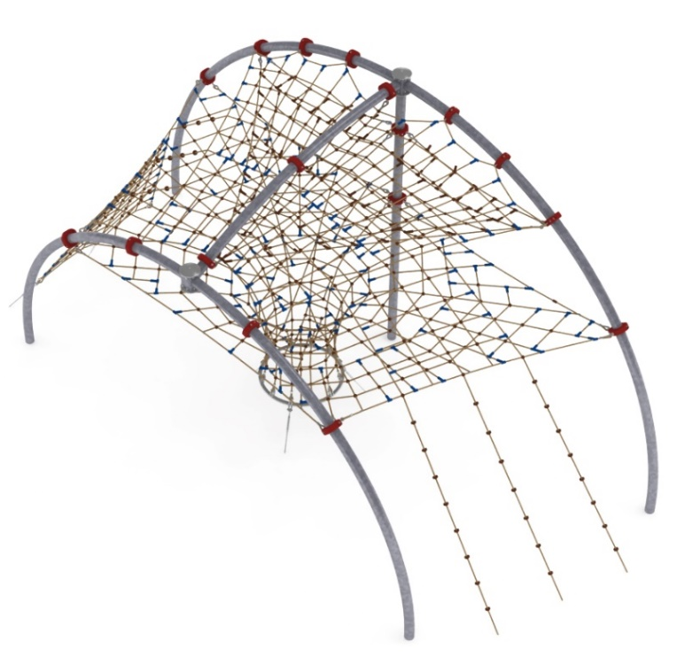
2. SECTION 2
The second section consists of:
- the main bottom net in the form of a flat, horizontal rope truss passing into a shaft extending to "level 0". The shaft is completed with mezzanines to prevent users from falling. Adjustment of the tension of the mesh is made possible by hot-dip galvanised turnbuckles.
- a rope net surrounding section 2, stretched between the steel arches. The net consists of alternately installed rope trusses and climbing ropes. The tension of the grid is adjusted by hot-dip galvanised turnbuckles.
- a horizontal rope truss installed between the main net and the surrounding net to limit falls from the top of the unit. The net is trapezoidal in shape with base dimensions of 5.4m and 2.2m and a height of 3.6m.

3. SECTION 3
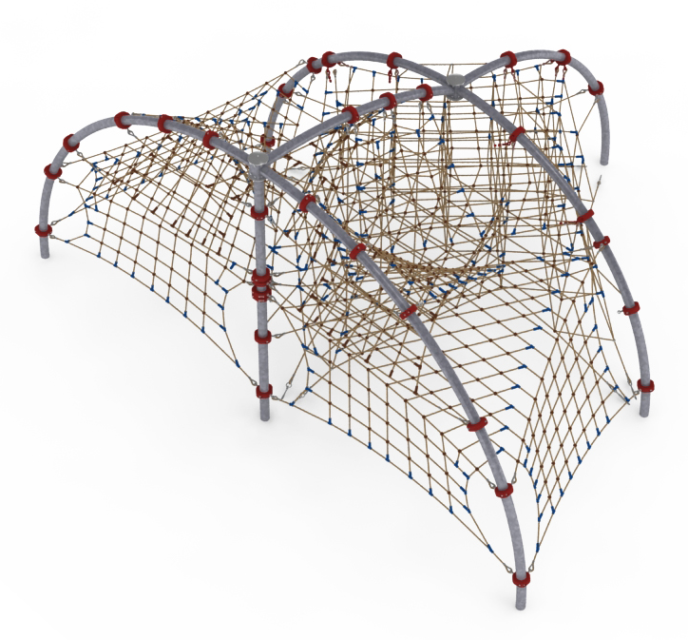
The third section consists of:
- the main net, which is formed by five levels that are connected by vertical cables and together form a spatial rope net.
- two configurations of flat nets made as mirror images with respect to the axis of the device. Each configuration is made up of:
* a triangular horizontal net installed at a height of 2.1 - 2.7m.
* two vertical cable grids installed to the sides of the triangular mesh, allowing access from "level 0".
* a twisted rectangular rope truss stretched between the top of the steel arch and the third side of the triangular net
* rectangular rope truss stretched between the twisted truss and the main net of the second section
- a triangular horizontal net installed at a height of 4.1m to limit the fall from the top of the device.

Rope sheathing technology.
Adjustment of the tension of the device is made possible by hot-dip galvanised turnbuckles. The nets are made of polyamide rope, braided, glued reinforced with galvanised steel strings. Rope diameter is 18 mm. The elements connecting the ropes to each other are made of plastic and aluminium. Elements connecting the ropes to the pole are made of stainless steel and cast steel painted with chlorine rubber.

4. Addition SLIDE
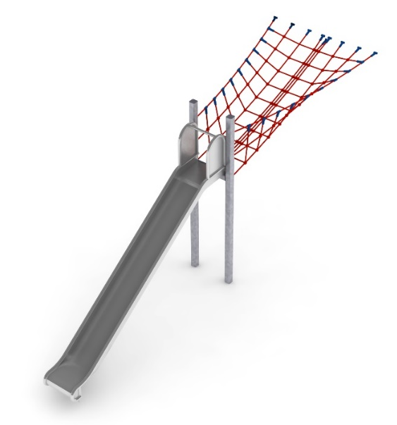
The main element of the addition is a slide made entirely of 0H18N9 grade acid-resistant steel. The start of the launching section is 2 m above ground level. The structural elements of the addition are made of 100x100 mm square pipe, which are protected against corrosion by hot-dip galvanising. The foundations are made as reinforced concrete footings founded at a depth of 1m. The passage is V-shaped and made of polyamide rope, braided, glued reinforced with galvanised steel strings. The rope diameter is 18 mm. The elements connecting the ropes to each other are made of plastic, stainless steel and aluminium.

5. Addition PIPE SLIDE
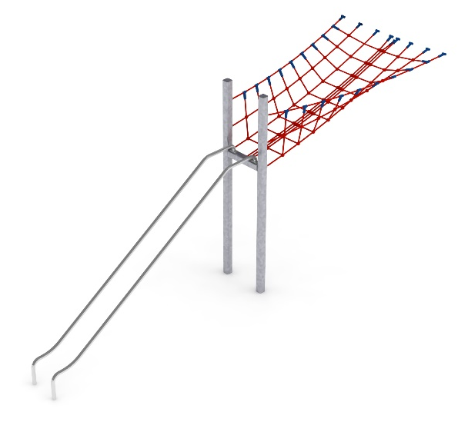
The main element of the add-on is a tubular slide made entirely of 0H18N9 grade acid-resistant steel. The tube slide is formed by two curved tubes with a diameter of 42.4 mm. The beginning of the starting section is 2 m above ground level. The structural elements of the addition are made of 100x100 mm square tube, which are protected against corrosion by hot-dip galvanisation. The foundations are made as reinforced concrete footings founded at a depth of 1m. The passage is V-shaped and made of polyamide rope, braided, glued reinforced with galvanised steel strings. The rope diameter is 18 mm. The elements connecting the ropes to each other are made of plastic, stainless steel and aluminium.

6. Addition FIREMAN PIPE
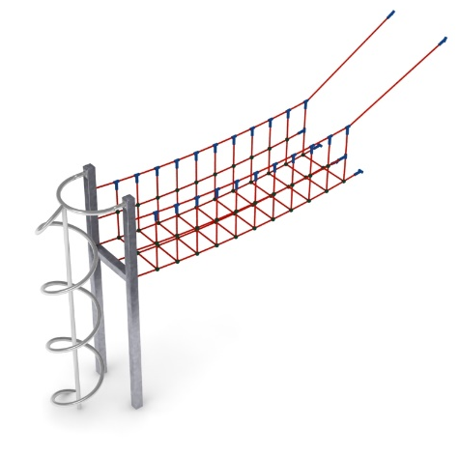
The main element of the addition is a spiral fireman's tube made entirely of acid-resistant steel of grade 0H18N9. The diameter of the spiral is 0.65 m. The launching platform is located 2 m above ground level. The structural elements of the addition are made of 100x100 mm square tube, which are protected against corrosion by hot-dip galvanisation. The foundations are made as reinforced concrete footings founded at a depth of 1m. The passage is U-shaped and made of polyamide rope, braided, glued reinforced with galvanised steel strings. The rope diameter is 18 mm. The elements connecting the ropes to each other are made of plastic and aluminium.

7. Addition TUBE SLIDE
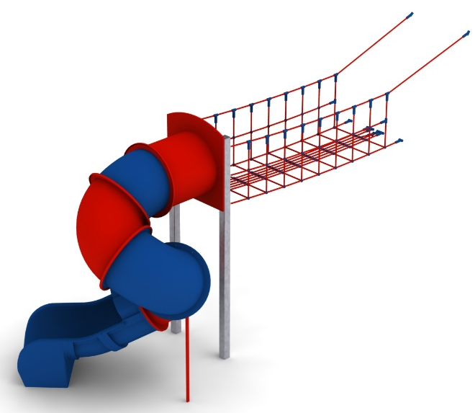
The main element of the addition is a spiral tube slide made of polyethylene. The start of the starting section is 2.15 m above ground level. The structural elements of the addition are made of 100x100 mm square tube, which are protected against corrosion by hot-dip galvanising. The foundations are made as reinforced concrete footings founded at a depth of 1m. The passage is U-shaped and made of polyamide rope, braided, glued reinforced with galvanised steel strings. The rope diameter is 18 mm. The elements connecting the ropes to each other are made of plastic and aluminium.

The fall area of the equipment should be made on a surface in accordance with PN EN 1176- 1:2017. The possibility of access by heavy construction equipment is required for the installation.
For the safety of children and the quality of the equipment, it is required that the equipment is certified in accordance with standards PN EN 1176-1:2017, PN EN 1176-3:2017, PN EN 1176-11:2014-11 issued by a system accredited by the National Accreditation Centre or the national accreditation body of the other Member States in accordance with Regulation (EC) No 765/2008 of the European Parliament and of the Council of the European Union."

